Hi Freaks

This Article says it all. How to do it cheaper, now there’s the rub !

Let’s dissassemble a cheap common or garden Solar Light. Figure1 shows what we can

expect to find inside. The output of the solar panel ranges between 1 to 5 Volts depending on

the ambient light conditions and we wish to deliver a fixed Voltage of 3 volts to the 2

Accumulators. So we must use the Buck-Boost Switching regulator configuration in Figure2

to achieve this. Figure3 shows a practical version of the circuit and the relevant assembly

language code is available in Mppt.asm

Figure1
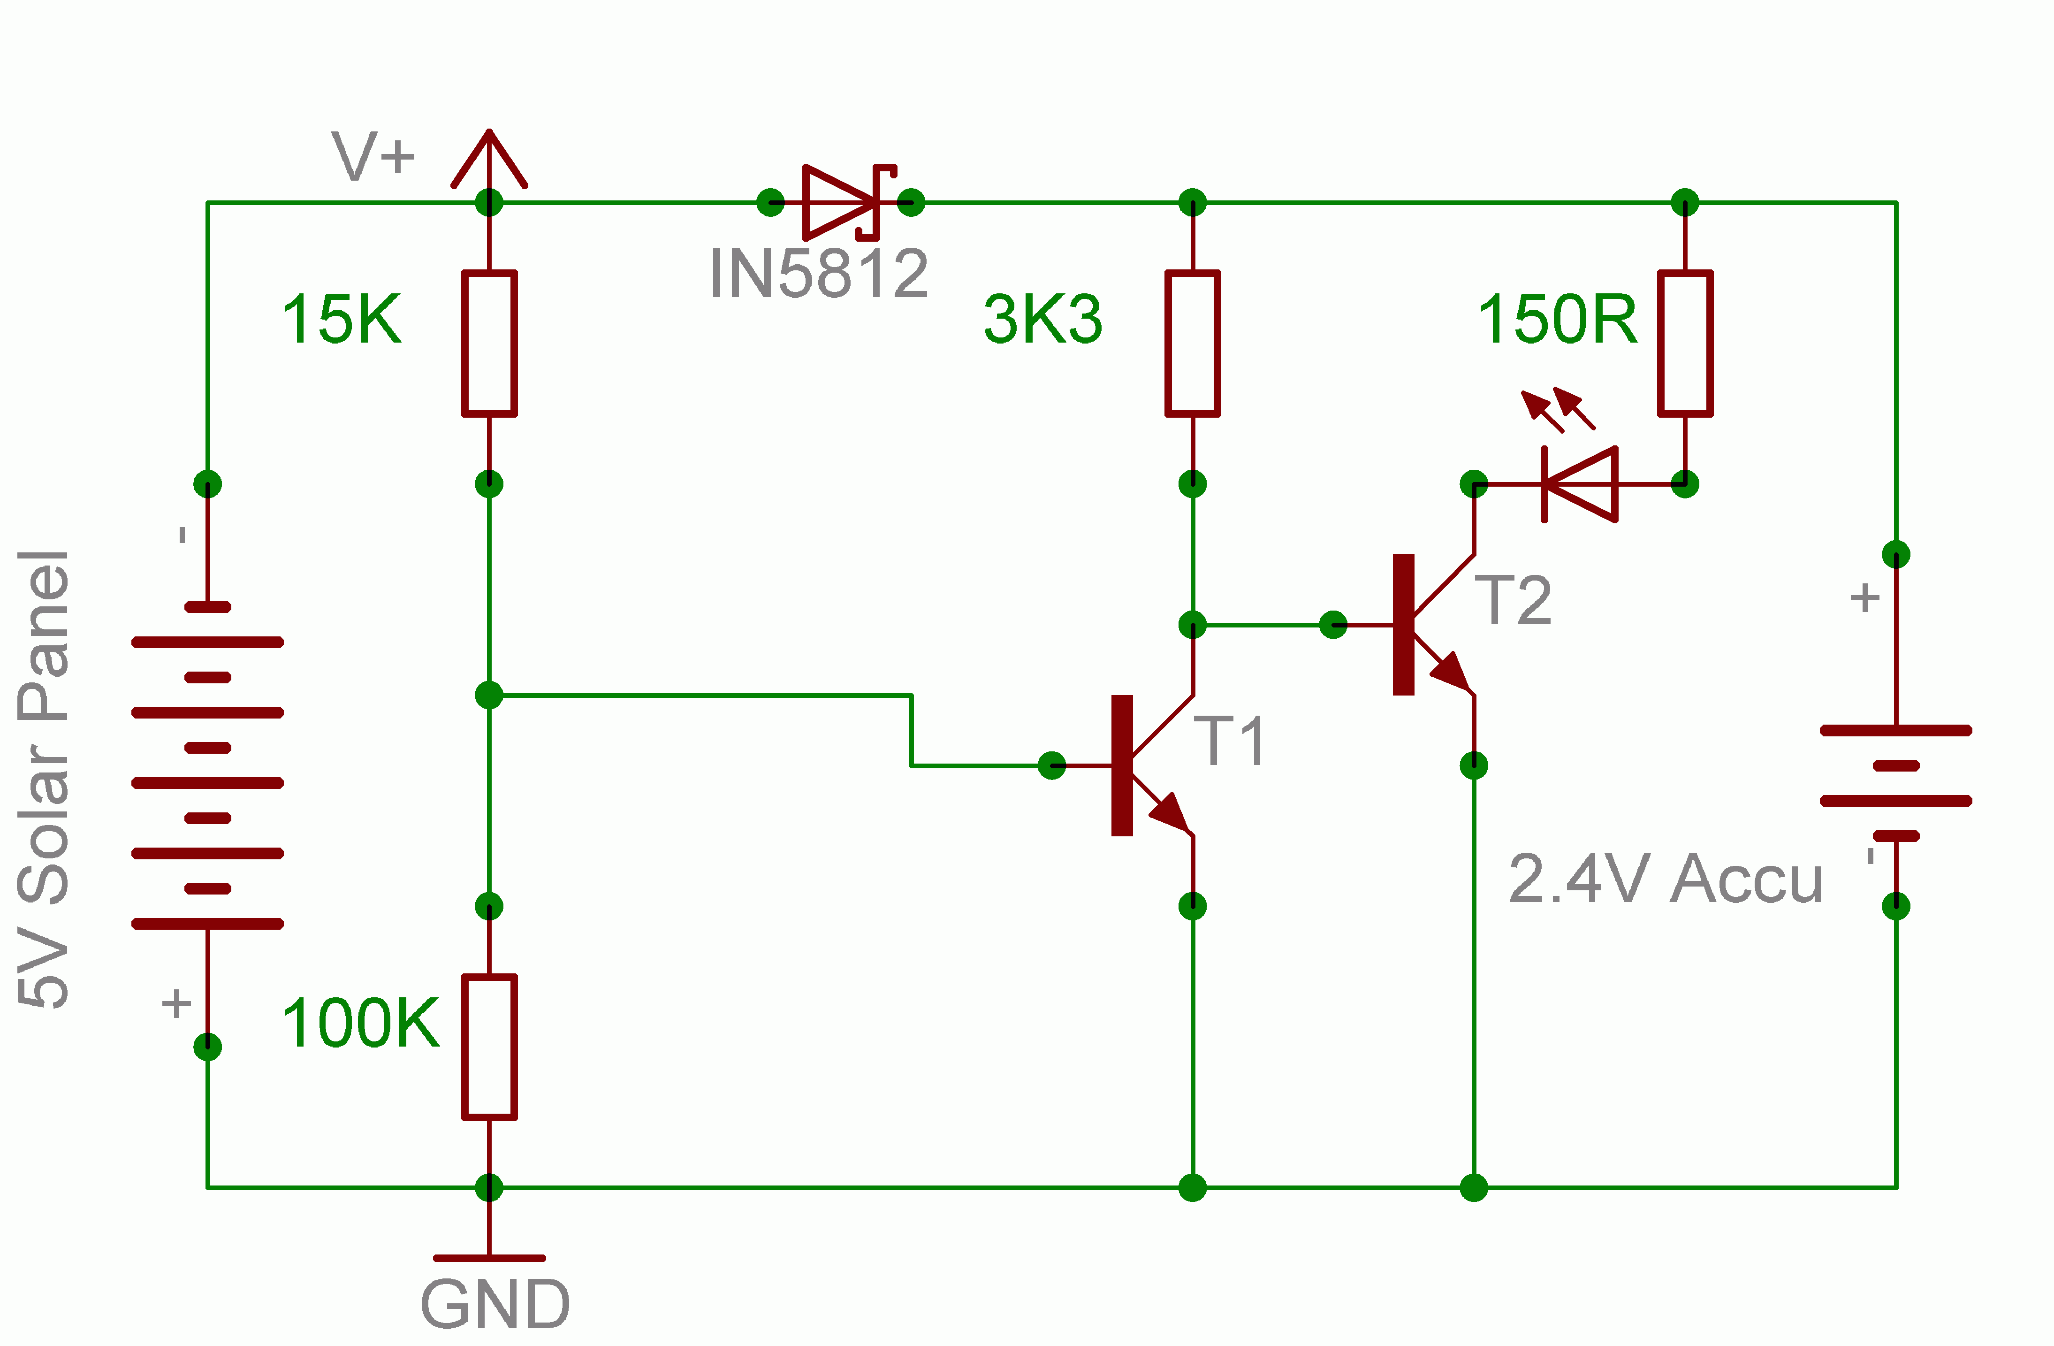

Figure2
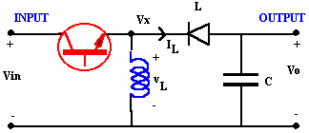

A useful Calculator with which to estimate various values of LC combinations

Figure3
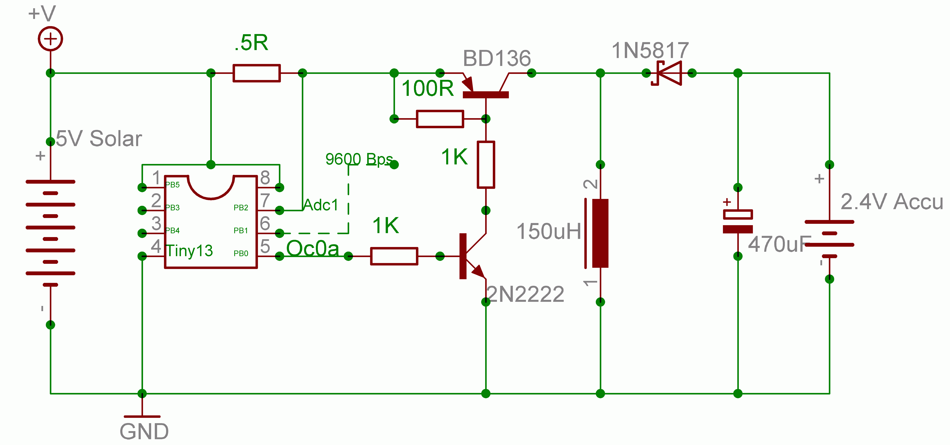

This project is presented as a Design idea and is really not really suitable for beginners

Enjoy.

John-Alfred Ullasmann

